

**Name:** Ayesha Nawaz Khan

**Subject:** Data Structures (Lab)

**Assignment:** Mid Term Exam

**Program:** Artificial Intelligence (B)

**Submitted to:** Sir Shayan

**Date:** 30-10-2025

**Questions Related to Mid Term Exam:**

**Q1. What is the patientID at the head?**

Ans. 10 is the patientid at the head.

**Q2. What is the patientID at the tail?**

Ans. 60 is the patientid at the tail.

**Q3. Write the list from head → tail (forward traversal)?**

Ans. 10 → 75 → 50 → 60.

**Q4. Write the list from tail → head (backward traversal)?**

Ans. 60 → 50 → 75 → 10.

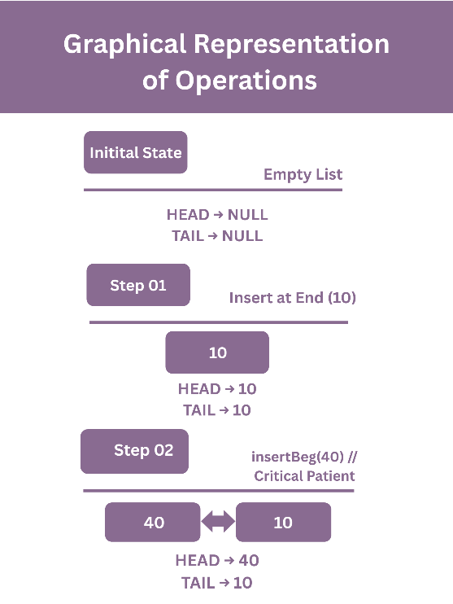**Qno 2) Dry Run or Trace You start with an empty ER list.**

